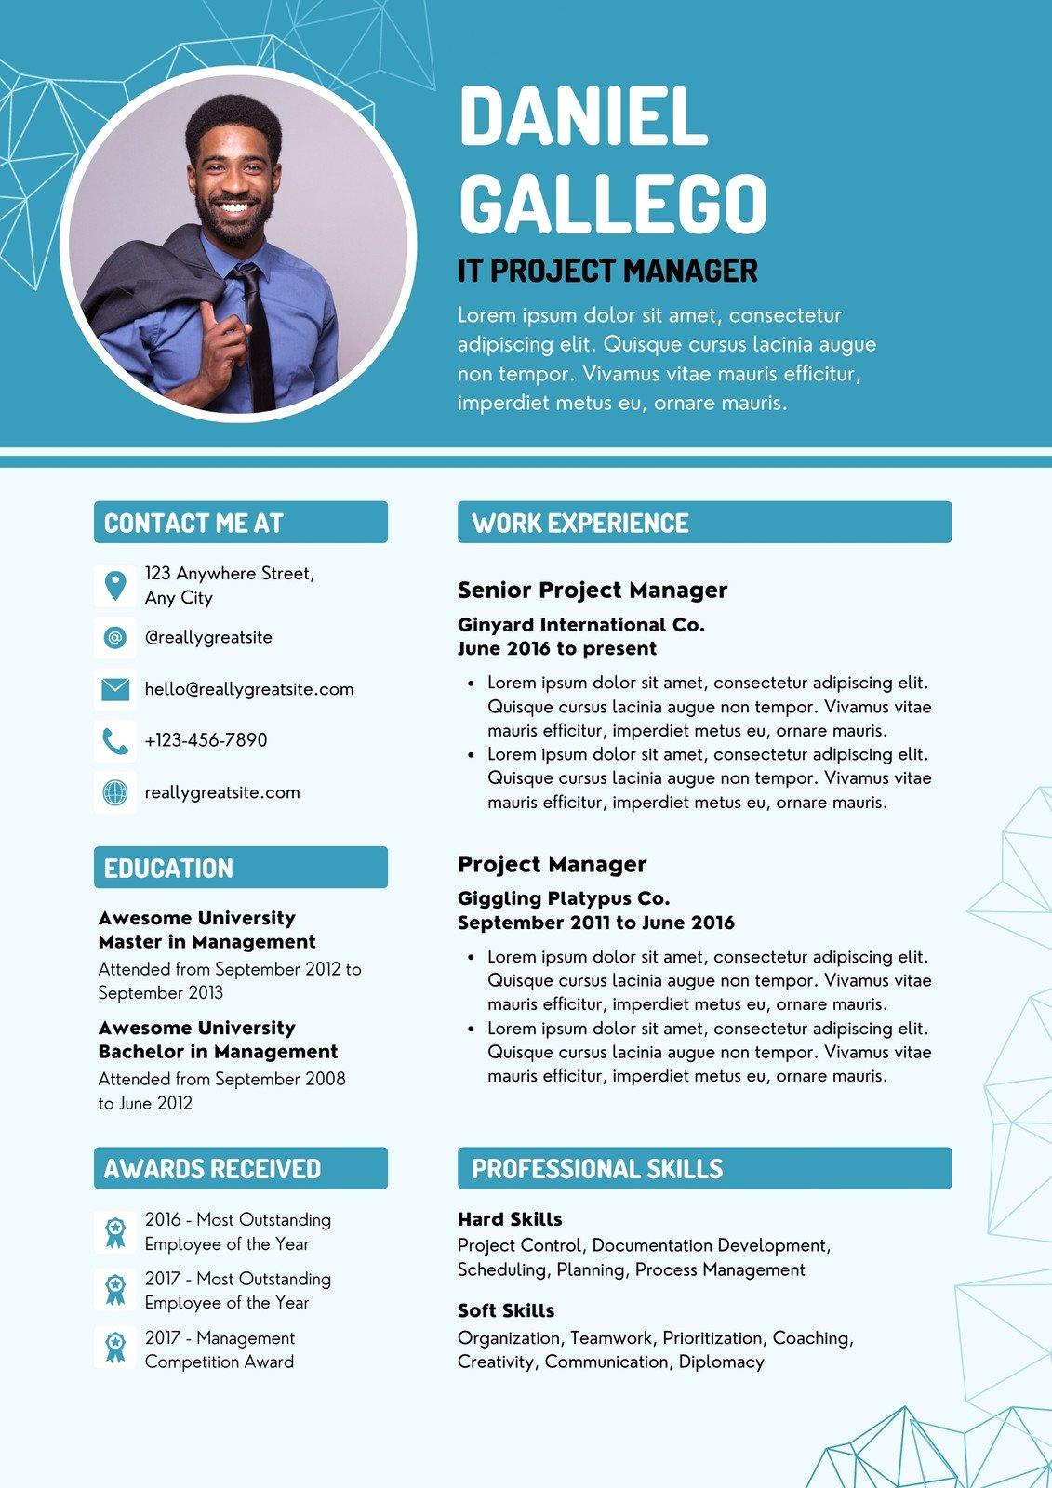
DANIEL GALLEGO
IT PROJECT MANAGER
Lorem ipsum dolor sit amet, consectetur adipiscing elit. Quisque cursus lacinia augue non tempor. Vivamus vitae mauris efficitur, imperdiet metus eu, ornare mauris.
CONTACT ME AT
@
123 Anywhere Street, Any City
@reallygreatsite
hello@reallygreatsite.com
+123-456-7890
reallygreatsite.com
EDUCATION
Awesome University Master in Management
Attended from September 2012 to September 2013
Awesome University Bachelor in Management Attended from September 2008 to June 2012
WORK EXPERIENCE
Senior Project Manager
Ginyard International Co. June 2016 to present
• Lorem ipsum dolor sit amet, consectetur adipiscing elit. Quisque cursus lacinia augue non tempor. Vivamus vitae mauris efficitur, imperdiet metus eu, ornare mauris.
• Lorem ipsum dolor sit amet, consectetur adipiscing elit. Quisque cursus lacinia augue non tempor. Vivamus vitae mauris efficitur, imperdiet metus eu, ornare mauris.
Project Manager
Giggling Platypus Co.
September 2011 to June 2016
• Lorem ipsum dolor sit amet, consectetur adipiscing elit. Quisque cursus lacinia augue non tempor. Vivamus vitae mauris efficitur, imperdiet metus eu, ornare mauris.
• Lorem ipsum dolor sit amet, consectetur adipiscing elit. Quisque cursus lacinia augue non tempor. Vivamus vitae mauris efficitur, imperdiet metus eu, ornare mauris.
AWARDS RECEIVED
2016 - Most Outstanding Employee of the Year
2017 Most Outstanding Employee of the Year
2017 Management Competition Award
PROFESSIONAL SKILLS
Hard Skills
Project Control, Documentation Development, Scheduling, Planning, Process Management
Soft Skills
Organization, Teamwork, Prioritization, Coaching, Creativity, Communication, Diplomacy

